**Git Assignement -1**

1. **Create a New Repository.**

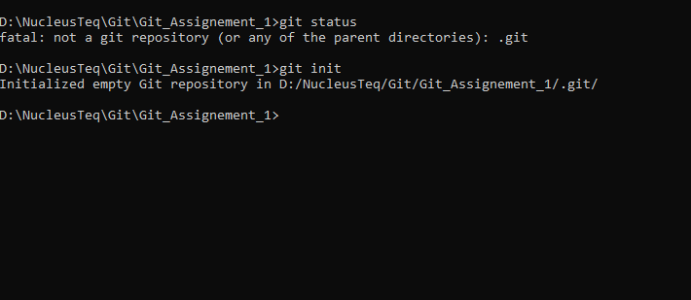

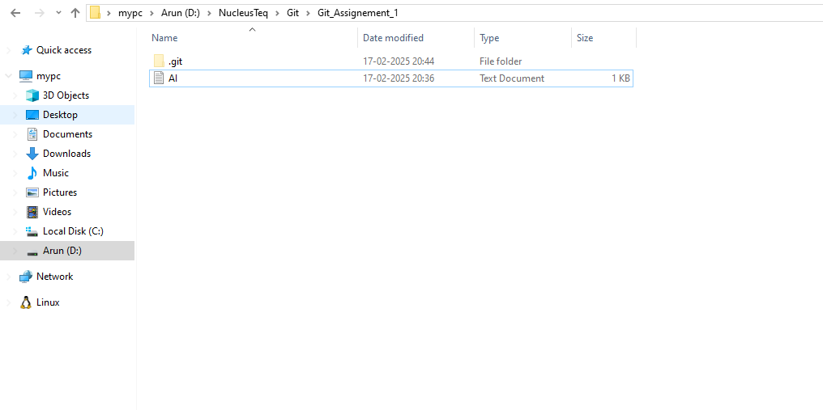

1. **Create a New File**

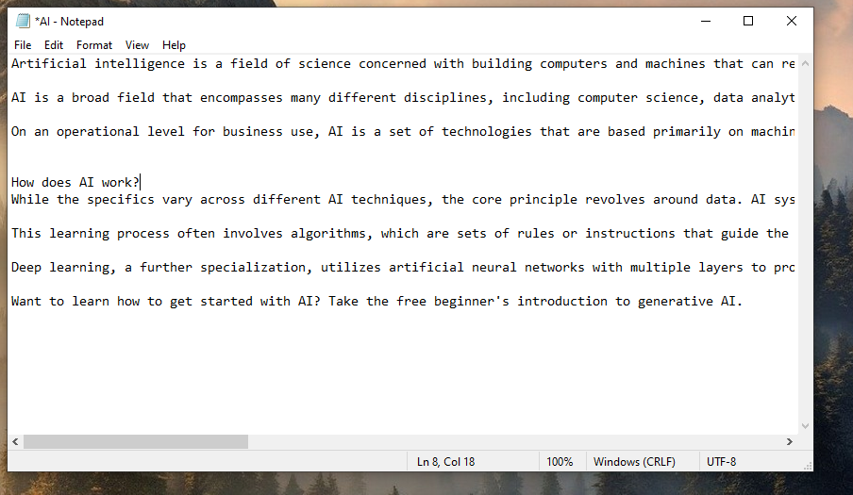

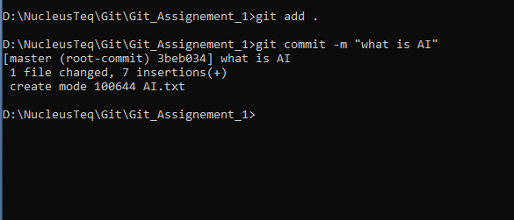

1. **Create a new Branch**

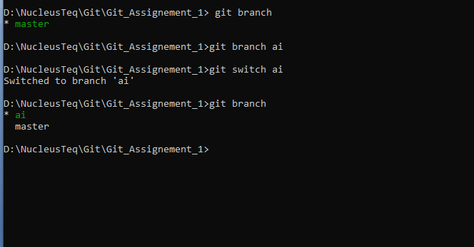

1. **Make changes into the new branch**
2. **Create a new txt file in AI branch (New Branch)**

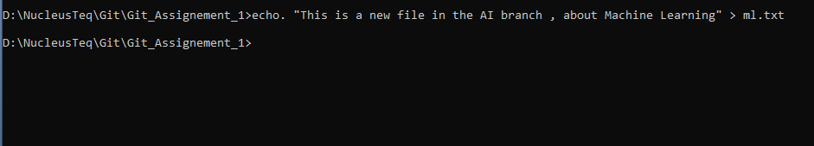

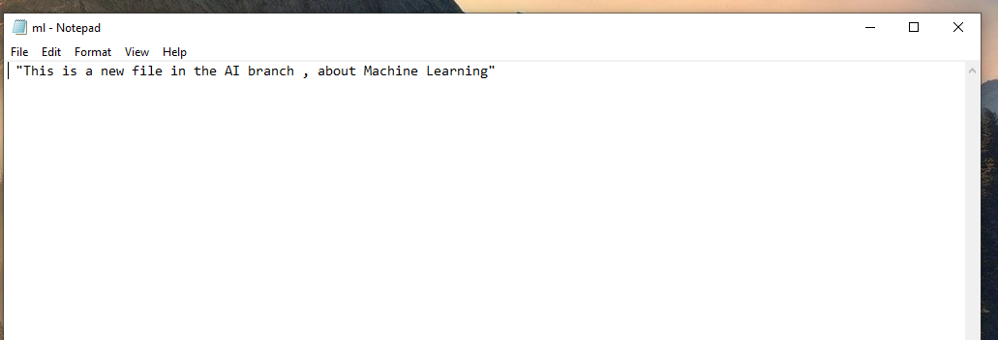

1. **Make changes in the ml.txt file**



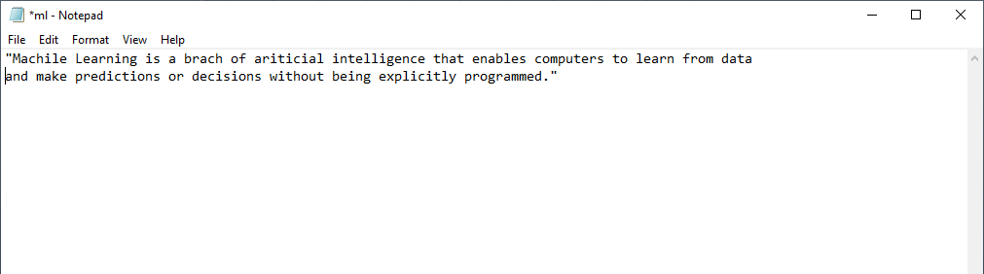

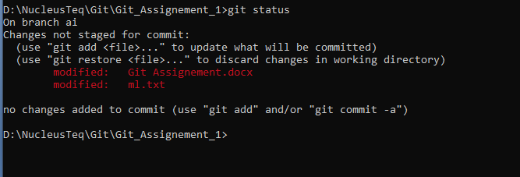

1. **Create a another branch .**

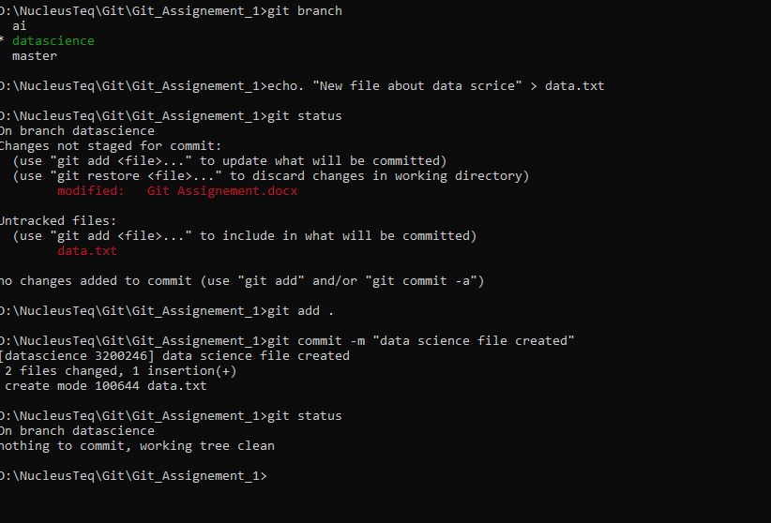

1. **Merge branches**